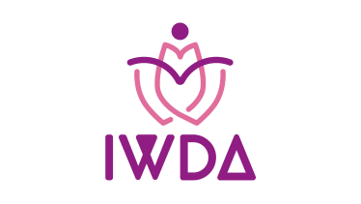

**APPLICATIONFORMFORIWDA–L’OREAL**

**LEADERSHIP GRANT 2024**

Paste

passport sized photograph here

Name:(blockletters)

Gender(M/F):

Date of birth (dd/mm/yyyy):

Nationality: Residing in:

Degrees in Dermatology:

Address(correspondence):

Phone numbers: Mobile:

Alternate PhoneNo:

Email ID:

**Qualifications:(Attachdocumentslistedbelow)**

|  |  |  |  |  |  |
| --- | --- | --- | --- | --- | --- |
| S. No. | Year | of | Year of | Current | Current |
|  | completion | of | completion of | Position held | employer(if |
|  | MBBS |  | MD/ DNB/ |  | employed) |
|  |  |  | Diploma in |  |  |
|  |  |  | Dermatology |  |  |
|  |  | |  |  |  |
|  |  | |  |  |  |

**Membership number of IADVL:**

**Membership numberof IWDA:**

(**IMPORTANT:**Only existing IWDA members are eligible to apply for the grant)

**Medical registration number & Authority**:

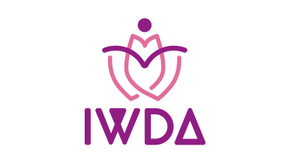

**APPLICATIONFORMFORIWDA–L’OREAL**

**LEADERSHIP GRANT 2024**

**Declaration:**

I hereby apply for the IWDA Leadership grant (inassociationwithL’Oréal) and agree to abide by the terms and conditions stipulated.

**I understand that the grant is open only to Indian nationals residing in India who are IADVL and IWDA members.** I also understand that my candidature for the grant can be cancelled if any discrepancy is detected in the details and documents furnished by me.

**Date/Place:**

**Signature of applicant:**

**Documentstobeattached:(Selfattestedphotocopies)**

1. Post-graduationdegreecertificateinDermatology
2. Medicalcouncilregistrationcertificate
3. Proofofresidence(passport/voterID/driving license)

**Forapplicant’sinformation:**

1. Pleasetakeprintsoftheform,fillitandsendthescannedformto

[**indianwomensderm@gmail.com**](mailto:indianwomensderm@gmail.com)**latestby15thJune2024.**

1. The applicants are also requested to writeanessayin500wordsonwhytheywishtotakethe leadership program and what is their professional aspiration that inspires them to develop themselves and email it along with the scanned copy of the form.
2. Pleasementioninthesubjectoftheemail“**ApplicationformforIWDA-L’OréalIndianWomen Dermatologists Leadership Grant**”
3. Selected applicants would be eligible to attend a **Professional and Personal Leadership programme online (virtual) once a week for 5 weeks in the months of August- September 2024** with a renowned Leadership Coach.
4. After attending the session, the applicants would be expected **to write in 1-2 paragraphs** about their experience and how the session benefitted them. This write-up would be published on the IWDA website.
5. The applicants would also be expected to **write any scientific paper** (case report/ original article/correspondence), preferably on Women’s dermatology or pigmentary disorders, and publish the paper in peer –reviewed journals, preferably International Journal of Women’s Dermatology (IJWD) or Pigment International (PI) or take alternate suggestions, with due acknowledgment to the IWDA-L’Oréal Leadership Grant. The applicants can also presenttheir work in future events heldundertheaegisofIWDAsubjecttoacceptance(detailstobe updated later).
6. **The certificate for the leadership grant would be subject to the applicants fulfilling the above-mentioned expectations or at least submission of the above. This wouldcontribute to professional and personal development.**